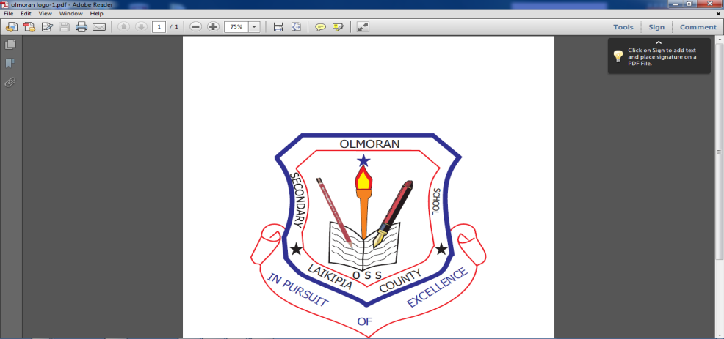
OL MORAN HIGH SCHOOL
P O BOX 149, KINAMBA,
TEL NO……0759010189

BOARDER’S FEES 2025
ITEM | TERM 1 | TERM 2 | TERM 3 | TOTAL
BOARDING | 11500 | 9500 | 6485 | 27485
RMI | 1200 | 800 | 400 | 2400
LTT | 320 | 200 | 130 | 650
ADM | 950 | 540 | 360 | 1850
EWC | 2450 | 1470 | 980 | 4900
ACTIVITY | 100 | 50 |  | 150
P.E | 1500 | 960 | 640 | 3100
TOTAL | 18020 | 13520 | 8995 | 40,535

School fees MUST be paid in full at
Equity Bank A/C No. 0160294021470 OR any Equity Agent e.g. at Dallas Shop OR Kigen petrol station Ol’moran.
And then bring the Bank pay-in slip to school in order to get the official school receipt: pay through pay bill enter business no. 247247, account no. 021470#adm no. then send
NO CASH MONEY IS ACCEPTED.
Yours faithfully

KIMATHI JOHN
PRINCIPAL

