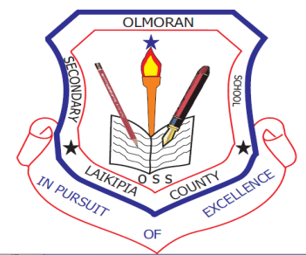
OL MORAN HIGH SCHOOL
P O BOX 149, KINAMBA,
TEL NO 0759010189

FEES STRUCTURE 2025

VOTEHEADS | TERM 1 | TERM 11 | TERM 111 | TOTAL
LUNCH  BOM TEACHERS  TOTAL (Ksh.) | 4000  500  4500 | 4000  500  4500 | 4000  500  4,500 | 12,000  1500  13,500

School fees MUST be paid in full at
Equity Bank A/C No. 0160294021470 OR any Equity Agent e.g. at Dallas Shop OR Kigen petrol station Ol’moran.
And then bring the Bank pay-in slip to school in order to get the official school receipt: pay through pay bill enter business no. 247247, account no. 021470#adm no. then send
NO CASH MONEY IS ACCEPTED.
Yours faithfully

KIMATHI JOHN
PRINCIPAL

